**Lesson 7 Demo 6**

**Docker Networking with SSHs**



Steps to be followed:

1. Creating a container and committing it
2. Creating a bridge network and finding its IP address
3. Connecting the network from another SSH server

**Step 1: Creating a container, and commit it**

1.1 Create a Centos Docker container. and install net-tools

***sudo docker run -it --name centos centos /bin/bash***

***yum install -y net-tools***

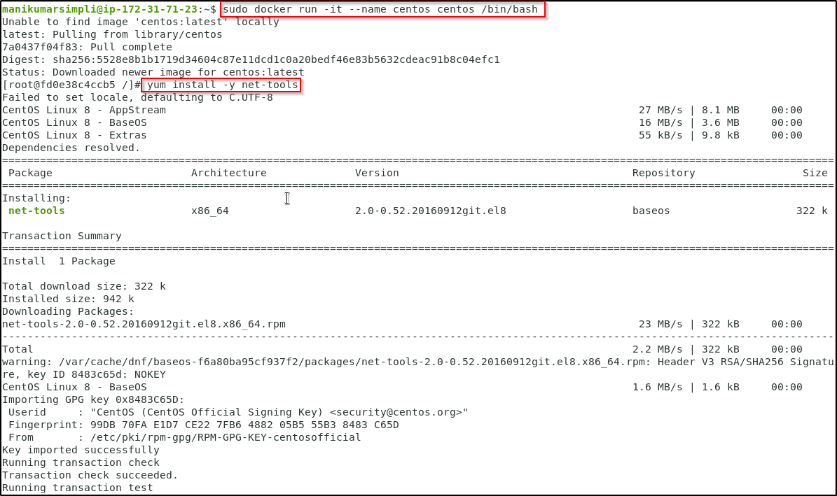

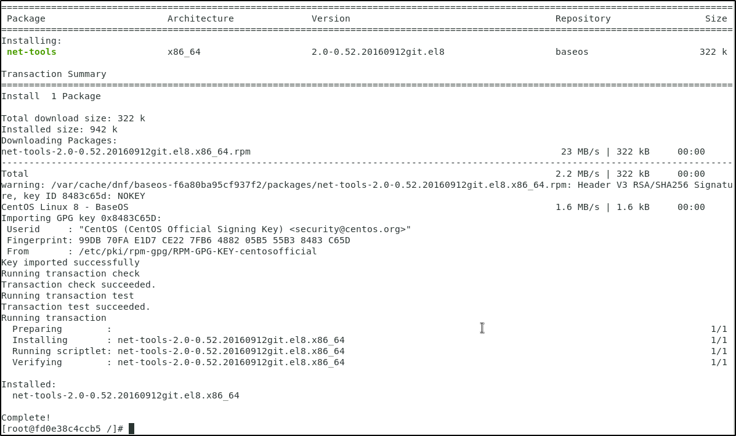

1.2 Check the IP address and hostname

***ifconfig***

***cat /etc/hosts***

***hostname***

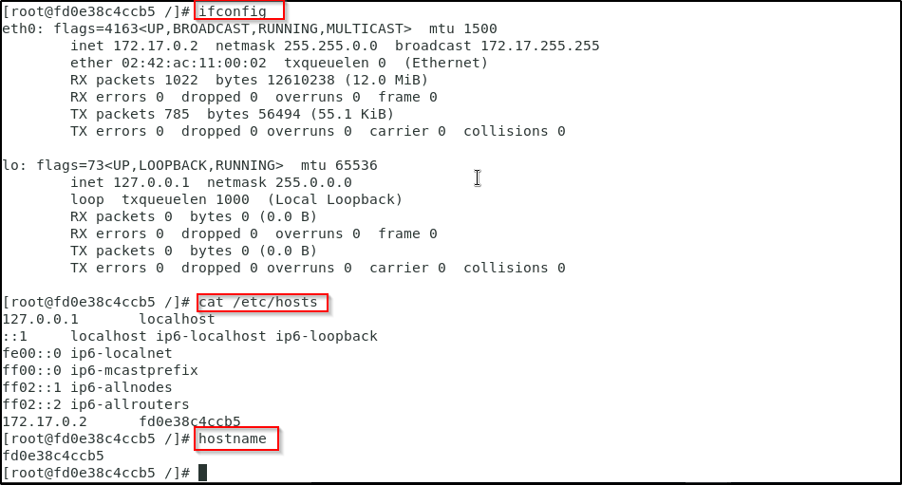

1.3 Exit the container using **CTRL+D**

1.3.1 Commit the container to an image (Please refer to the screenshot)

***docker commit centos centos-net***

***docker images***

***docker rm centos***

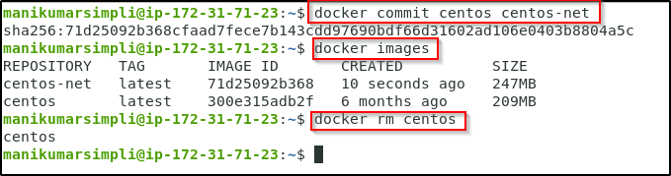

**Step 2: Creating a bridge network, and find its IP address**

2.1 Create a bridge network, and find its IP range

***docker network create exnet***

***docker network ls***

***docker network inspect exnet***

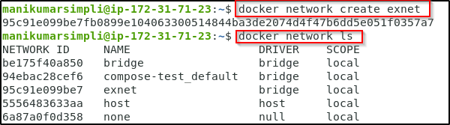

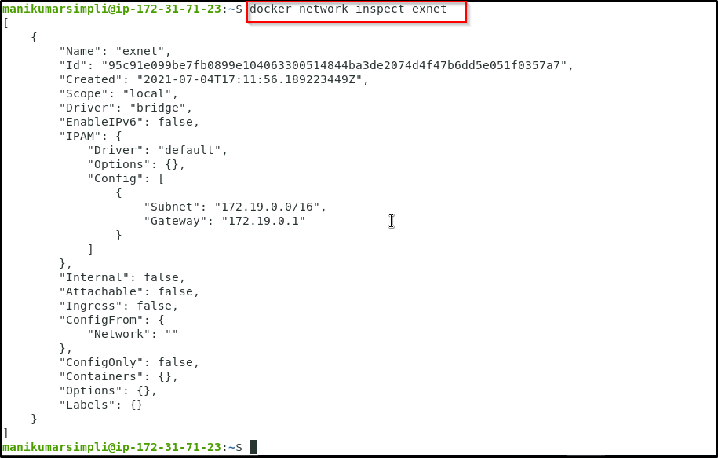

2.2 Run the centos container using the new network

***docker run -it --rm --network exnet centos-net /bin/bash***

2.3 Check the IP address and hostname

***ifconfig***

***cat /etc/hosts***

***hostname***

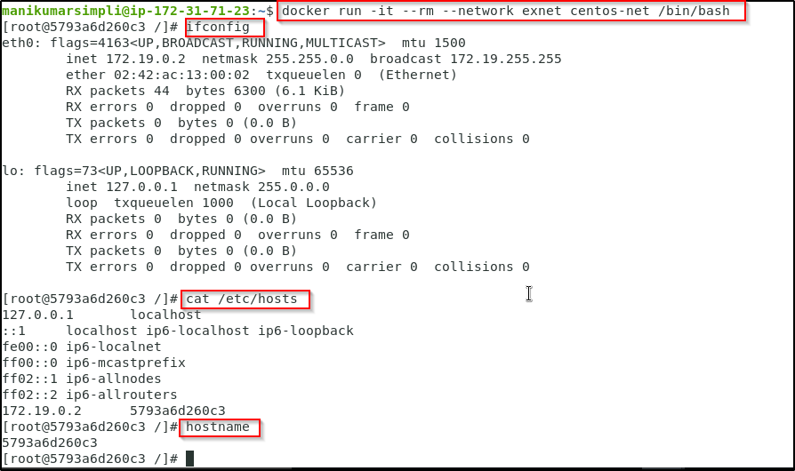

2.4 Exit the container using **CTRL+D**

2.4.1 Start a new container using the default network

***docker run -it --rm --name centos centos-net /bin/bash***

2.5 Check the IP address and hostname

***ifconfig***

***cat /etc/hosts***

***hostname***

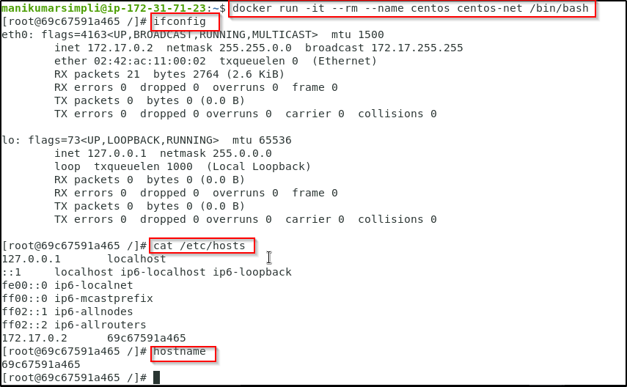

**Step 3: Connecting the network from another SSH server**

3.1 Click on + to open another Terminal window. Type the below given command to from the second SSH terminal to connect the network to the container

***docker network connect exnet centos***

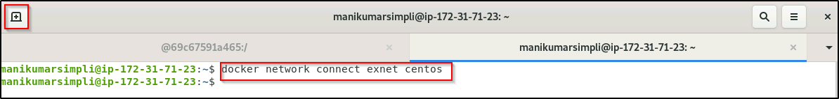

3.2 Go back to the running container. You will see that it now has two IP addresses (Please refer to the screenshot)

***ifconfig***

***cat /etc/hosts***

***hostname***

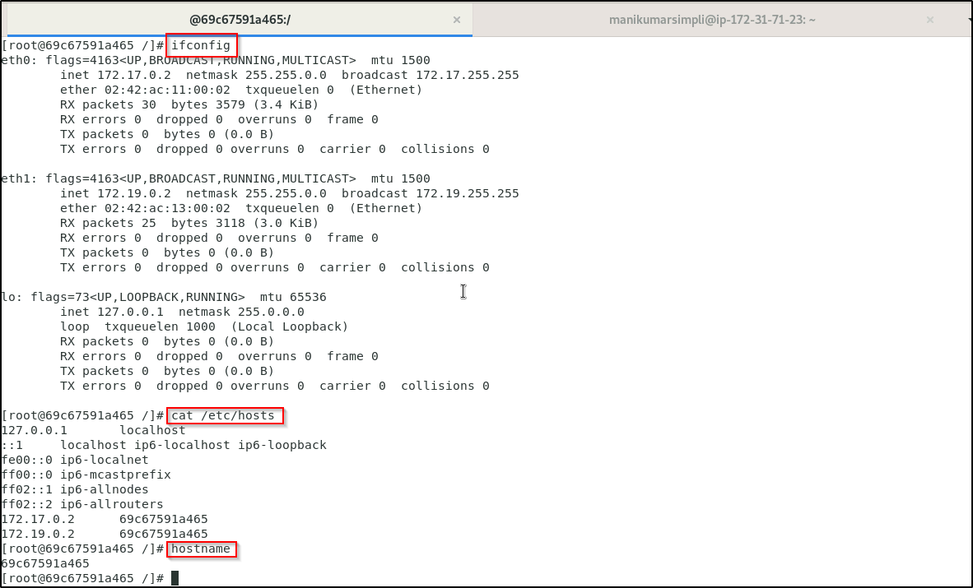

3.3 Go to the second SSH window, and disconnect the network

***docker network disconnect exnet centos***

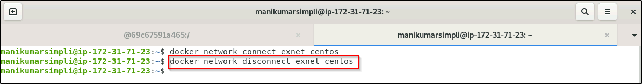

3.4 Go back to the running container, and see that it now has one IP address

***ifconfig***

***cat /etc/hosts***

***hostname***

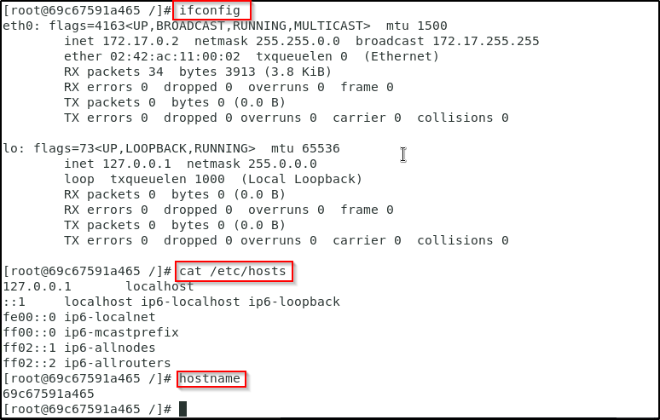

3.5 Exit the container using CTRL+D